**TOUR CHUA KEO- DONG BANG TEMPLE- MAU TIEN LA TEMPLE- TRAN THAI BINH TEMPLE**

*Attention:*

-Departure point: Hanoi.

-Time: 1 day and night.

-Media: car.

-Price: 360000đ.

-Image:

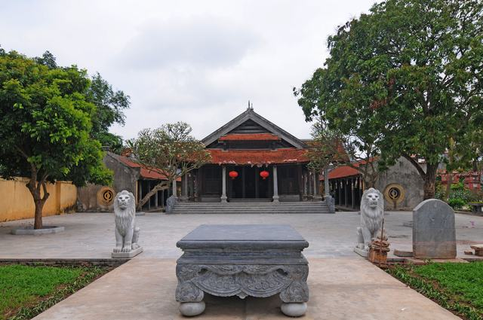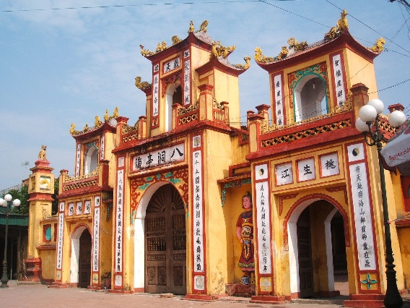

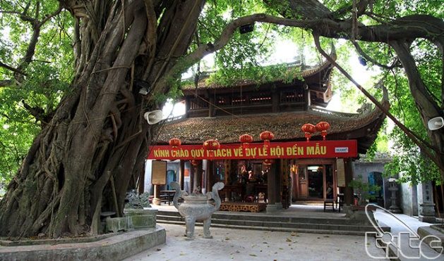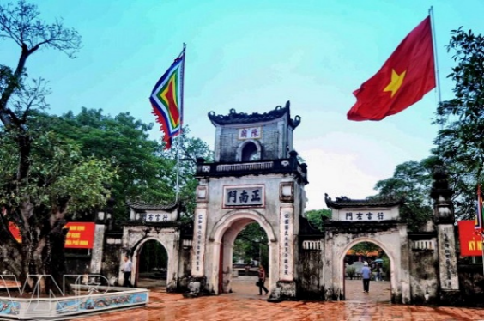

**I.INTRODUCE:**

**Tour Chua Keo- Dong Bang temple- Mau Tien La temple- Tran Thai Binh temple**

- Dong Bang Temple, located in Dong Bang Village, An Le Commune, Quynh Phu District, is a beautiful wood sculpture art museum, an attractive tourist destination of Thai Binh rice countryside. Dong Bang Temple is a place of worshiping of Father Cha Hai Hai Dong Dinh, who has great merit in maintaining the country and recruiting people to build Giang Son Tac village from the beginning.

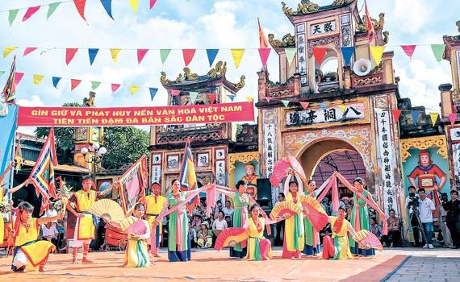

- Keo Pagoda is located in Duy Nhat commune, Vu Thu district which is considered the largest and most beautiful temple in the Northern Delta of Vietnam. Keo Pagoda worships Great Master Khong Lo - one of the great ancestors of Vietnamese Buddhism; a famous physician was told to cure "fleeting panic, ten thousand elimination diseases"; a great poet of the Ly dynasty ... Besides worshiping Buddha and Great Master Khong Lo, Keo Pagoda also had an altar of Lai Thi Ngoc Le, who regretted thousands of gold to buy good timber, and hired good craftsmen to build a temple to worship Buddha.



- Keo Pagoda is located in Duy Nhat commune, Vu Thu district which is considered the largest and most beautiful temple in the Northern Delta of Vietnam. Keo Pagoda worships Great Master Khong Lo - one of the great ancestors of Vietnamese Buddhism; a famous physician was told to cure "fleeting panic, ten thousand elimination diseases"; a great poet of the Ly dynasty ... Besides worshiping Buddha and Great Master Khong Lo, Keo Pagoda also had an altar of Lai Thi Ngoc Le, who regretted thousands of gold to buy good timber, and hired good craftsmen to build a temple to worship Buddha.

**II.** **Tour schedule:**

**1.Day 1:** **Chua Keo- Dong Bang temple- Mau Tien La temple- Tran Thai Binh temple** _____________________________________________________________________

Detailed schedule:

05h00: Car and guide Viet Center pick you up at the meeting point and depart for Thai Binh. Group stop to have breakfast and rest (expenses excluded).

08h00: Get on the bus to Hung Ha, visit and burn incense at Tran Temple, including the Temple and the tomb to worship the Tran kings, this place is the homeland, the development of the Tran Dynasty in Vietnamese history. Male. Continue to burn incense and bridge Tai - Loc at Mau Tien La Temple - the place to worship Bat Nam Shogun (A general of Hai Ba Trung).

10h00: Visit Keo Pagoda - the pagoda was built in the Ly dynasty, and is now considered one of the typical architectures of Tonkin Pagoda.

12h00: Have lunch at the restaurant.

After lunch, take the bus down Highway 10, to Quynh Phu, burn incense, Loc bridge - Tai bridge at Dong Bang Temple - the place of worshiping the famous Holy Father Bat Hai Dong Dinh that every year thousands of visitors cross towards the ceremony.

18h30: The bus will take you back to the original destination, goodbye and see you again on the next trip.

_____________________________________________________________________

**III.** **INCLUDED AND TERMS:**

**Service includes:**

• New vehicles transport along the journey. Safe and responsible driving.

• The standard lunch level: 120,000 VND.

• Tickets to the first entry under the program.

• Experienced tour guide, enthusiastic to serve the delegation during the tour.

• Travel insurance. Maximum level of compensation: VND 20,000,000 / person / case.

• Drinking water: 02 bottles / 01 day / 01 person.

• Cold towels 02 pieces / day / person.

• Gifts in the car: Hats Viet Center Tourist.

• Preventive health care.

**The service does not include:**

• 10% VAT.

• Sights outside the program, personal expenses: Drinks, phone.

• Fragrance, offerings, additional costs.